Sreeti Ravi

Project Summary:

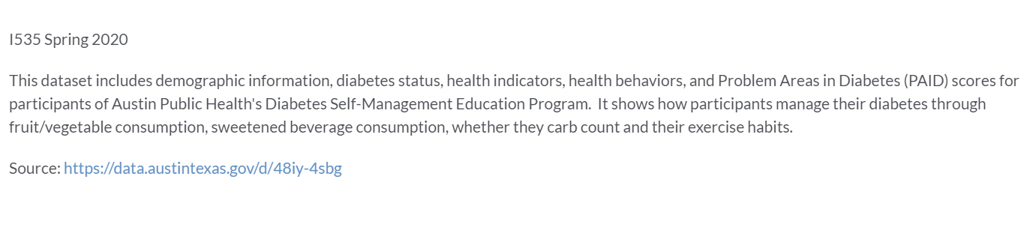

Query:

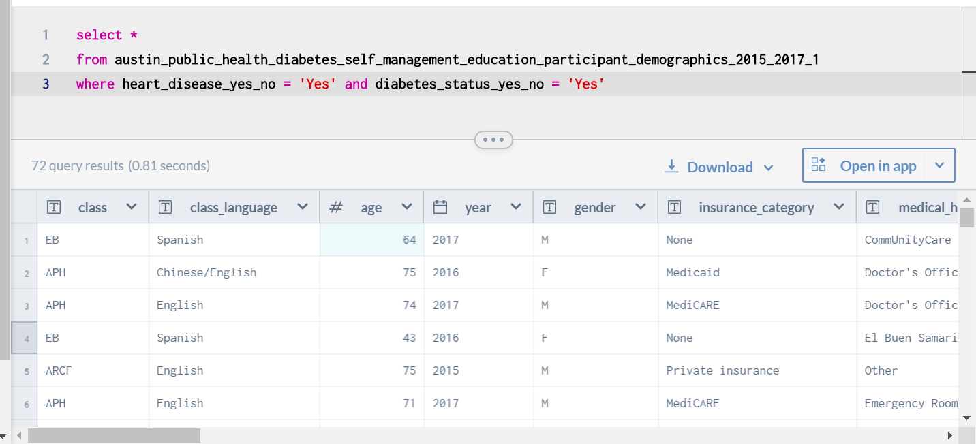

Data Dictionary:

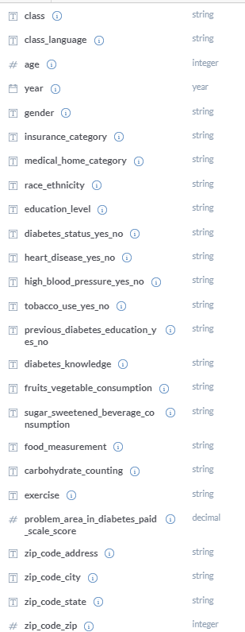

I really like the purpose and mission of this website to building an abundant data resource that anyone can access. It is one place where people can find all kinds of data and it provides people with a community to collaborate and share their ideas with others. The public or private option gives people the choice to choose whether they want to their work to be viewed or used by others. This website gives people the chance to work together on real world problems with other like-minded individuals. Another great use for this website would be to allow people from different parts of the world to view the same data and share ideas.

I used a dataset that showed the demographic information, diabetes status, health indicators, health behaviors, and Problem Areas in Diabetes scores for participants of Austin Public Health’s Diabetes Self-Management Education Program. This data is structured because it is in a pre-defined format and has an organized predictable layout. The data was presented in a CSV format and is computer-generated.